**ASHA –LATA**

Institute for Education, Development & Rehabilitation of Challenged Children

Sector – 5/D, Bokaro Steel City – 827006, Dist - Bokaro, Jharkhand, India

Phone (o) 06542 – 287766

Email id: bsjayasawal@gmail.com, [ashalatakendra@yahoo.co.in](mailto:ashalatakendra@yahoo.co.in)

Website: [www.ashalatabokaro.com](http://www.ashalatabokaro.com)

**SUCCESS STORIES**

Since a humble beginning, made sixteen years back, ASHA-LATA has been successful in its Mission to Empower Differently able children; One hundred eleven Specially able children passed std. X. 5 did MA, 31 Graduated in different disciplines, 28 did DCA and 5 did Diploma in Engineering. Out of 111, 71 have been economically rehabilitated, 8 employed in Govt. jobs, 23 are doing higher studies, including 8 being trained in ITI, about 100% success rate. Orthopedically handicapped Komal Kumari after completing Dip. In Engg is joining B. Tech course. Brajesh Pandey, National Cycling Champion is invited to participate in Special Olympics 2015, USA. Our 34 ex students have also been socially rehabilitated & settled in life. ASHA-LATA is full of successful & inspiring stories; some of them are illustrated below.

**EDUCATIONAL ACHIEVEMENTS**

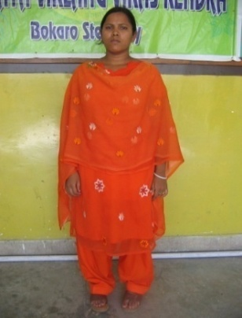 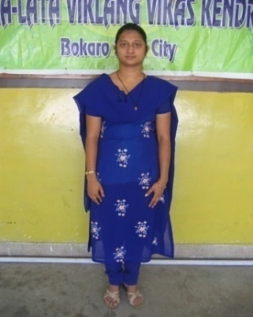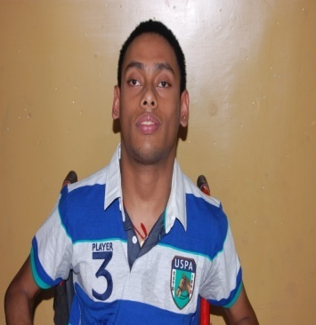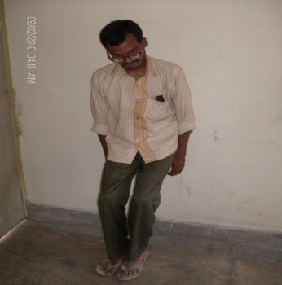

**Sharda Kumari(OH) Sweety Kumari(HI) Adarsh Vishnu(CP) Rakesh Kumar,**

**1st Disable girl got 1st HI girl got passed 2014, 10th 1st Multiple**

**Dip in Comp. Engg Dip in Comp. Engg Board. A rare case Disable passed**

**In Jharkhand in Jharkhand in JHARKHAND 10th JAC Board**

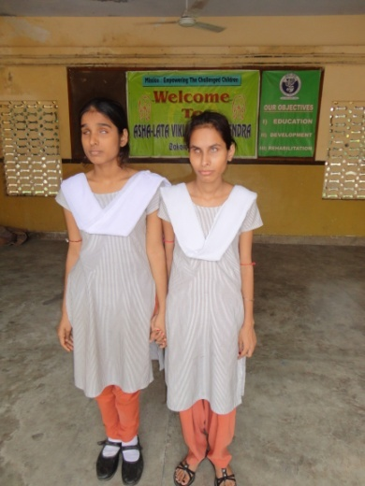

**Nishtha & Krishna(VI)**

**Secured 1st & 3rd Rank in 10th**

**Board in Jharkhand.**

**ACADEMIC PERFORMANCE**

**Results of physically challenged Children in different Exams:-**

1. **Matriculation 111**

(100% result in 2007)

1. **Intermediate 52**

(100% result in 2007,2008,2009,2012,2013 & 2014)

1. **B.A./B.Sc./B.Com 22**
2. **M.A. 01**
3. **B.Ed. 03**
4. **B.C.A 01**
5. **Diploma in Engineering ( All girl students) 05**

**8.**  **Diploma in Computer application 28**

1. **I.T.I Course 03**

**10. B.A in Music 05**

**11. M.A in Music 04**

**Achievements 2014-2015 (Education)**

Srl. Examination Passed No. of Students

1. 10th Board 15

2. 12th Board 10

**Achievements 2013-2014 (Education)**

Srl. Examination Passed No. of Students

1. 10th Board 07

2. 12th Board 01

3. B.A. 01

4. M.A. 01

5. Diploma in Engineering 01

**Achievements 2012-2013 (Education)**

1. 10th Board 10

2. 12th Board 03

3. B.A./B. Sc/B.Com 07

**HIGHLIGHTS OF EDUCATION**

* A Cerebral Palsy student with Multiple Disabilities, Adarsh Vishnu passed Std. X Board 2014 with 53.6% Marks. It is a rare case in the country. It could be achieved due to his brave determinations & full support of his parents.
* In 2013 a record number of ten students have passed 10th board examinations, out of which six visually impaired students got first division. **In Jharkhand merit list** **our student Nishtha Kumari has secured first position whereas Kumari Krishna Dubey has bagged third spot.**
* During 2006-2007, the result of Matric and Class-XII was 100%.
* The result of Class – XII Board Exam in 2007, 2008, 2009, 2012,2013,2014 were 100%.
* One visually impaired student Ved Prakash has obtained 71st rank in B.A (Hons.) 2013 in Vinoba Bhave University.
* For the first time, a multiple disable Rakesh kumar passed Matriculation Exam in the Year 2007.
* Sharda Kumari an orthopedically disabled girl student Passed Diploma in Engineering in computer science with above 70% Marks.
* Sweeti kumari a hearing impaired girl student passed Diploma in Engineering in computer science with 72% marks which is first of its kind in Jharkhand
* A visually impaired student Chandrakant Thakur did M.A in Pol. Science and B.Ed.

**Differently able Students passed out from ASHA-LATA**

**Result of 10th Board Examination 1999-2000**

|  |  |  |
| --- | --- | --- |
| 1. | Ghanshyam Kumar | Visually impaired |
| 2. | Chandrakant Thankur | Visually impaired |
| 3. | Shambhu Kumar Gupta | Visually impaired |

**Result of 10th Board Examination 2000-01**

|  |  |  |
| --- | --- | --- |
| 1. | Nitu Kumari | Deaf & Dumb |
| 2. | Sunaina Kumari | Deaf & Dumb |
| 3. | Amritesh Kumar Jha | Deaf & Dumb |
| 4. | Sudeepta Pal | Deaf & Dumb |
| 5. | Kaushal Kishore | Deaf & Dumb |
| 6. | Vijay Kumar | Deaf & Dumb |
| 7. | Vikash Kumar Prajapati | Visually impaired |
| 8. | Sanjay Prajapati | Visually Impaired |
| 9. | Rakesh Mishra | Visually Impaired |

**Result of 12th Board Examination 2000-01**

|  |  |  |
| --- | --- | --- |
| 1. | Ghanshyam Kumar | Visually impaired |

**Result of 12th Board Examination 2001-02**

|  |  |  |
| --- | --- | --- |
| 1. | Shambhu Kumar Gupta | Visually impaired |
| 2. | Chandrakant Thankur | Visually impaired |

**Result of 10th Board Examination 2002-03**

|  |  |  |
| --- | --- | --- |
| 1. | Sauvik Ietch | Deaf & Dumb |
| 2. | Mamta Kumari | Deaf & Dumb |

**Result of 12th Board Examination 2002-03**

|  |  |  |
| --- | --- | --- |
| 1. | Sanjay Prajapati | Visually Impaired |
| 2. | Rakesh Mishra | Visually Impaired |
| 3. | Shri Bhagwan | Visually Impaired |
| 4. | Mantosh Kumar | Visually Impaired |
| 5. | Shourabh Sinha | Visually Impaired |

**Result of 10th Board Examination 2003-04**

|  |  |  |
| --- | --- | --- |
| 1. | Pushpraj | Deaf & Dumb |
| 2. | Sweeti Kumari | Deaf & Dumb |
| 3. | Sudhir Prasad | Deaf & Dumb |
| 4. | Rajesh Kumar | Deaf & Dumb |
| 5. | Amit Kumar | Deaf & Dumb |
| 6. | Rajnish Kumar | Deaf & Dumb |
| 7. | Pankaj Kumar | Deaf & Dumb |
| 8. | Toni Kumari | Deaf & Dumb |
| 9. | Sunil Kr. Sinha | Visually Impaired |
| 10. | Shivendra Kumar | Visually Impaired |
| 11. | Upendra Kumar | Visually Impaired |
| 12. | Sharda Kumari | Orthopedically Impaired |

**Result of 10th Board Examination 2004-05**

|  |  |  |
| --- | --- | --- |
| 1. | Shri Mukesh Kumar | Hearing impaired |
| 2. | Gautam Raj | Hearing impaired |
| 3. | Mamta Kumari | Visually Impaired |

**Result of 10th Board Examination 2005-06**

|  |  |  |
| --- | --- | --- |
| 1. | Vijay Kumar | Hearing impaired |
| 2. | Jitendra Kumar | Hearing impaired |
| 3. | Abhishek Kumar | Hearing impaired |
| 4. | Dolly Kumari | Hearing impaired |
| 5. | **Lakhi Kumari** | **Hearing impaired** |
| 6. | **Satyedra Kumar** | **Hearing impaired** |
| 7. | **Rakesh Kumar** | **Hearing impaired** |
| 8. | **Pramod Kumar** | **Hearing impaired** |
| 9. | **Ganga Ram** | **Hearing impaired** |
| 10. | Dharmendra Kumar | Orthopedically Impaired |
| 11. | Panchan Kumari | Orthopedically Impaired |
| 12. | Lalita Kumari | Orthopedically Impaired |
| 13. | Ved Prakash | Visually Impaired |
| 14. | Shahnaz Parveen | Visually Impaired |
| 15. | Kavita Kumari | Visually Impaired |
| 16. | Naveen Kr. Jha | Visually Impaired |
| 17. | Md. Faisal Ansari | Visually Impaired |
| 18. | Naveen Kr. Pd. | Orthopedically Impaired |
| 19. | Sanjoti Kumari | Hearing impaired |

**Result of 12th Board Examination 2005-06**

|  |  |  |
| --- | --- | --- |
| 1. | Pushp Raj | Hearing impaired |
| 2. | Rajnish Kumar | Hearing impaired |
| 3. | Amit Kumar | Hearing impaired |
| 4. | Sweeti Kumari | Hearing impaired |
| 5. | Shivendra Kumar | Visually Impaired |
| 6. | Sunil Kr. Sinha | Visually Impaired |
| 7. | Upendra Kr. | Visually Impaired |
| 8. | Sharda Kumari | Orthopedically Impaired |

**Result of 10th Board Examination 2006-07**

|  |  |  |
| --- | --- | --- |
| 1. | Ravi Kumar | Hearing impaired |
| 2. | Lalita Kumari | Hearing impaired |
| 3. | Sunil Kumar Mishra | Hearing impaired |
| 4. | Jay Prakash Roy | Hearing impaired |
| 5. | Mithlesh Kr. Roy | Visually Impaired |
| 6. | Rajesh Kumar | Visually Impaired |
| 7. | Krishna Kumar | Orthopedically Impaired |
| 8. | Sukant Kumar Biswas | Hearing impaired |
| 9. | Rakesh Kumar | Hearing impaired |
| 10. | Neel Kamal Bauri | Hearing impaired |
| 11. | Ramnath Goswami | Hearing impaired |

**Result of 12th Board Examination 2006-07**

|  |  |  |
| --- | --- | --- |
| 1. | Mamta Kumari | Visually Impaired |
| 2. | Vikas Kumar Prajapati | Visually Impaired |

**Result of 10th Board Examination 2007-08**

|  |  |  |
| --- | --- | --- |
| 1. | Rakesh Kumar | Multiple Disable |
| 2. | Praveen Kumar | Orthopedically Impaired |
| 3. | Ravindra Kumar | Orthopedically Impaired |

**Result of 12th Board Examination 2007-08**

|  |  |  |
| --- | --- | --- |
| 1. | Ved Prakash | Visually Impaired |
| 2. | Dharmendra Kumar | Orthopedically Impaired |
| 3. | Rajesh Kumar | Hearing impaired |
| 4. | Jitendra Kumar | Hearing impaired |
| 5. | Kavita Kumari | Visually Impaired |
| 6. | Pramode Kumar | Deaf & Dumb |

**Result of 10th Board Examination 2008-09**

|  |  |  |
| --- | --- | --- |
| 1. | Komal Kumari | Orthopedically Impaired |
| 2. | Jawahar Lal Gope | Orthopedically Impaired |
| 3. | Sanoj Kumar | Orthopedically Impaired |
| 4. | Rahul Kumar | Hearing impaired |
| 5. | Neelam Kumari | Hearing impaired |

**Result of 12th Board Examination 2008-09**

|  |  |  |
| --- | --- | --- |
| 1. | Mithlesh Kr. Ray | Visually Impaired |
| 2. | Krishna Kumar | Orthopedically Impaired |
| 3. | Ravi Kumar | Hearing impaired |
| 4. | Pratik Kumar | Hearing impaired |
| 5. | Prabhat Kumar | Hearing impaired |
| 6. | Sudhir Prasad | Hearing impaired |
| 7. | Ravi Kumar Sharma | Hearing impaired |

**Result of 10th Board Examination 2009-10**

|  |  |  |
| --- | --- | --- |
| 1. | Saket Anand | Hearing impaired |
| 2. | Sinodh Kumar | Hearing impaired |
| 3. | Brajesh Kr. Pandey | Mentally Retarded |

**Result of 12th Board Examination 2009-10**

|  |  |  |
| --- | --- | --- |
| 1. | Praveen Kumar | Orthopedically Impaired |
| 2. | Lalita Kumari | Hearing impaired |
| 3. | Ravi Kumar | Hearing impaired |
| 4. | Vijay Kumar | Hearing impaired |

**Result of 10th Board Examination 2010-11**

|  |  |  |
| --- | --- | --- |
| 1. | Shourabh Kumar | Mentally Retarded |

**Result of 10th Board Examination 2011-12**

|  |  |  |
| --- | --- | --- |
| 1. | Urmila Kumari | Orthopedically Impaired |
| 2. | Dinesh Kumar | Orthopedically Impaired |
| 3. | Rahul Kumar | Orthopedically Impaired |
| 4. | Pramjeet Singh | Mentally Retarded |
| 5. | Shiva Nand | Deaf & Dumb |
| 6. | Manju Kumari | Deaf & Dumb |
| 7. | Rahul Uphadhyay | Deaf & Dumb |

**Result of 12th Examination 2011-12**

|  |  |  |
| --- | --- | --- |
| 1. | Nirmala Kumari | Orthopedically Impaired |
| 2. | Sanoj Kumar | Orthopedically Impaired |

**Result of 10th Board Examination 2012-13**

|  |  |  |
| --- | --- | --- |
| 1. | Nishtha Sharma | Visually Impaired |
| 2. | Krinshna Kumari Dubey | Visually Impaired |
| 3. | Payal Parmanik | Visually Impaired |
| 4. | Uttra Kumari | Visually Impaired |
| 5. | Yasmin Parween | Visually Impaired |
| 6. | Jitendra Kumar | Visually Impaired |
| 7. | Sunita Kumari | Orthopedically Impaired |
| 8. | Mukesh Kumar | Orthopedically Impaired |
| 9. | Aman Kumar | Deaf & Dumb |
| 10. | Vijay Kumar | Visually Impaired |

**Result of 12th Board Examination 2012-13**

|  |  |  |
| --- | --- | --- |
| 1. | Jawahar Gope | Orthopedically Impaired |
| 2. | Rajesh Kumar | Orthopedically Impaired |
| 3. | Satyanarayan Pandey | Orthopedically Impaired |

**Result of 10th Board Examination 2013--14**

|  |  |  |
| --- | --- | --- |
| 1. | Nimish Kumar | (VI) 72.8% |
| 2. | Dharmshila Kumari | (VI) 58% |
| 3. | Adarsh Vishnu | (CP) 53.6% |
| 4. | Aditya Prakash | (HI) 46% |
| 5.. | Anuj Kumar Prasad | (HI) 42.6% |
| 6. | Kanchan Kumari | Hearing Impaired |
| 7. | Ravi Kumar Sharma | Hearing Impaired |

**Result of 12th Board Examination 2013--14**

|  |  |  |
| --- | --- | --- |
| 1. | Dinesh Kumar | (OH) 2nd Division |

**Achievement 2014 – 15**

**Education**

**Annual Secondary Exam – 2015, Jharkhand Academic Council (Ranchi)**

|  |  |  |  |
| --- | --- | --- | --- |
| **S. No** | **Name** | **Category** | **Result** |
| 01. | Kailash Kumar | Visually Impaired | First Division (80%) |
| 02. | Mahendra Kr. Digar | Visually Impaired | First Division (77.4%) |
| 03. | Vishal Kumar | Orthopedically Impaired | First Division (72.2%) |
| 04. | Abhay Kumar Tiwari | Hearing Impaired | First Division (72.2%) |
| 05. | Shubham Kant Murmu | Visually Impaired | First Division (70%) |
| 06. | Mithilesh Kumar Pandey | Hearing Impaired | First Division (69.6%) |
| 07. | Suman Kumari | Orthopedically Impaired | First Division (69.2%) |
| 08. | Sushma Kumari | Hearing Impaired | First Division (64.6%) |
| 09. | Joshna Kumari | Hearing Impaired | First Division (60.4%) |
| 10. | Shivam Kumar Giri | Hearing Impaired | Second Division (59.8%) |
| 11. | Nitish Kumar | Hearing Impaired | Second Division (59.2%) |
| 12. | Naveen Kumar | Hearing Impaired | Second Division (58.6%) |
| 13. | Bhola Kumar Pandit | Hearing Impaired | Second Division (57.7%) |
| 14. | Sushma Kumari | Visually Impaired | Second Division (56.4%) |
| 15. | Sunil Kumar | Hearing Impaired | Second Division (53.8%) |

|  |  |  |  |  |
| --- | --- | --- | --- | --- |
| Category | Appear | 1st Division | 2nd Division | Total pass |
| Visually Impaired | 04 | 03 | 01 | 04 (100%) |
| Hearing Impaired | 10 | 04 | 05 | 09 (90%) |
| Orthopedically Impaired | 02 | 02 | .. | 02 (100%) |
| Total | 16 | 09 | 06 | 15 (94%) |

**Achievement 2014 – 15**

**Education**

**Jharkhand Board 12th Exam Result**

|  |  |  |  |
| --- | --- | --- | --- |
| **S. No** | **Name** | **Category** | **Result** |
| 01 | Nishtha Sharma | Visually Impaired | First Division (74.4%) |
| 02 | Rahul Kumar | Orthopedically Impaired | First Division (72%) |
| 03 | Kumari Krishana Dubey | Visually Impaired | First Division (69.2%) |
| 04 | Vijay Kumar Sen | Visually Impaired | First Division (66.6%) |
| 05 | Mukesh Kumar | Orthopedically Impaired | Second Division (58%) |
| 06 | Payal Pramanik | Visually Impaired | Second Division (56%) |
| 07 | Uttra Kumari | Visually Impaired | Second Division (56%) |
| 08 | Yasmin Parveen | Visually Impaired | Second Division (52.2%) |
| 09 | Jitendra Kumar Saw | Visually Impaired | Second Division (47%) |
| 10 | Sunita Kumari | Orthopedically Impaired | Third Division (38.4%)` |

|  |  |  |  |  |  |
| --- | --- | --- | --- | --- | --- |
| Category | Appear | 1st Division | 2nd Division | 3rd Division | Total pass |
| Visually Impaired | 07 | 03 | 04 |  | 07 (100%) |
| Orthopedically Impaired | 03 | 01 | 01 | 01 | 03 (100%) |
| Total | 10 | 04 | 05 | 01 | 10 (100%) |

**DEVELOPMENTAL ACHIEVEMENTS**

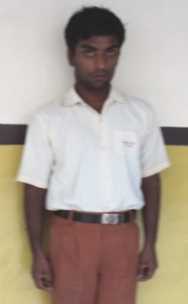 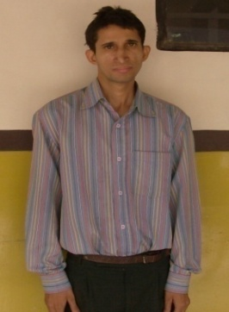 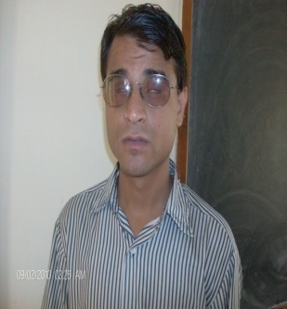 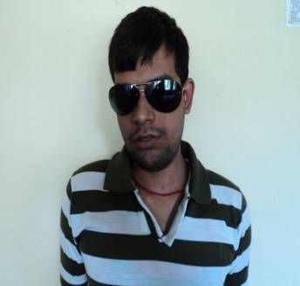

**Brajesh Pandey Kamran Iqbal SHIVENDRA KR SUNIL KUMAR**

**GOLD MEDALIST GOLD MEDALIST MA (Music) Teacher MA (Music)**

**National Games National Games Indian Railway Music Teacher**

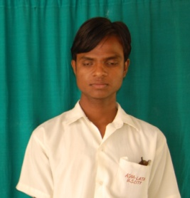

**Mahendra Digar ( VI)**

**National 1st Prize**

**As Orator in English**

**HIGHLIGHTS OF DEVELOPMENT**

* Two students, Brajesh Pandey (M.R) and Eqbal Hassan (M.R) bagged three bronze medals in cycling at ***National Level Cycling championship*** held at Bhopal.
* In Sports competition organized by ***“Special Olympic Bharat”*** at Jamshedpur, our students bagged ***8 prizes***, (One gold, six silver and one bronze).

* Sri. Sunil Kumar M.A (Music) - Our Ex student and presently Music Teacher of ASHA-LATA, bagged third prize in ***National Music competition for Visually Impaired*** organized by Anurag Sangeet Samiti, Jaipur ***on the occasion of completion of 100 years of Hindi cinema.***
* In “***On the*** ***Spot Painting competition***” organized by Jharkhand State Child welfare Council, at Raj Bhavan, Ranchi, our students bagged two gold, one silver, two bronze and one consolation prize.
* In the District level ***“On the spot Painting competition”*** organized by “Art City” at Bokaro, our student Manju Kumari (Hearing Impaired) bagged the first prize.
* Manju Kumari, a hearing impaired student of ASHA-LATA, who passed matriculation this year bagged 1st prize in painting competition organized by Jharkhand State Council for child welfare at Raj Bhavan, Ranchi.
* Mahendra Kr. Digar a visually impaired student of ASHA-LATA participated in National Assembly organized by **National Bal Bhavan at Manglore (Karnataka)** and got 1st prize in speech competition.

|  |  |  |  |  |
| --- | --- | --- | --- | --- |
| **Sports** | | | | |
| Gold | National | State | District & Local Level | Total |
| 12 | 04 | 59 | **75** |
| Silver | 09 | 10 | 54 | **73** |
| Bronze | 12 | 02 | 32 | **46** |
| Consolation prize | 01 | -- | 38 | **39** |
| **Total** | | | | **233** |

|  |  |  |  |  |
| --- | --- | --- | --- | --- |
| **Music** | | | | |
| Gold | National | State | District & Local Level | Total |
| 01 | 06 | 04 | **11** |
| Silver | -- | 11 | 04 | **15** |
| Bronze | 01 | 11 | 06 | **18** |
| Consolation prize | -- | 02 | 18 | **20** |
|  | **Total** | | | **64** |

|  |  |  |  |  |
| --- | --- | --- | --- | --- |
| **Painting** | | | | |
| Gold | National | State | District & Local Level | Total |
| -- | 03 | 12 | **15** |
| Silver | -- | 02 | 09 | **11** |
| Bronze | -- | 03 | 08 | **11** |
| Consolation prize | -- | 01 | 18 | **19** |
|  | **Total** | | | **56** |

**ECONOMIC REHABILIATION**

* 71 Students of ASHA-LATA have been rehabilitated in the main stream of society, 8 are in Govt. job including 4 in Indian Railways.

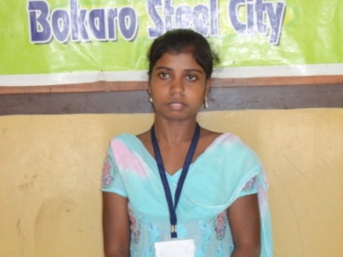 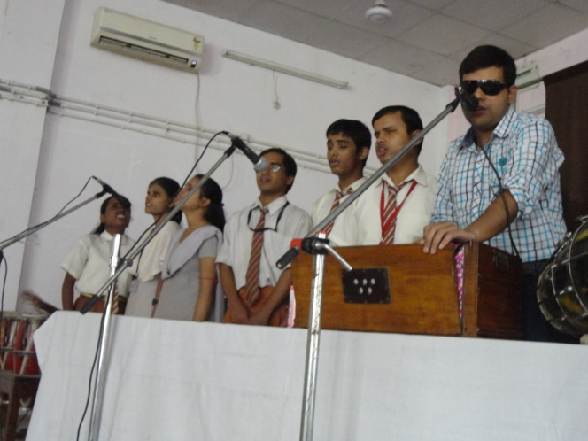

**Nirmala Kumari (OH) passed XII Visually Impaired Sunil Kumar & Manoj**

**Board 1st Div. Did DCA, joined MA in Music, Employed as**

**Indian Railways. Teachers**

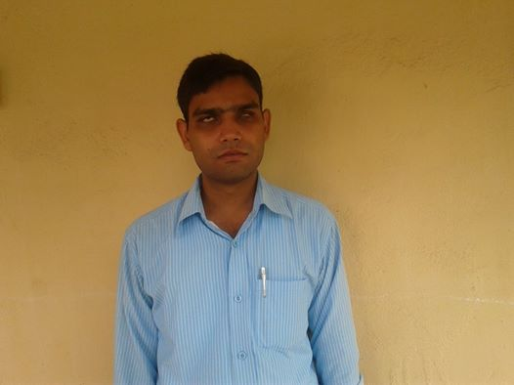

**Visually Impaired Mithilesh Kumar did BA**

**Employed in Indian Railways**

* First Time in Jharkhand State a Co-operative Society was formed by 51 students of ASHA-LATA. They are successfully running a Sudha Dairy Milk Booth. Seven of them are employed in Milk Booth run by this Co-operative.
* Sharda Kumari, also an orthopedically disabled ex-student, who has the distinction of being the first girl disabled student in Jharkhand to complete diploma in computer Engineering, is successfully running a computer training center along with a Cyber Cafe.
* 5 students were appointed in different organizations in 2013. One of them is an orthopedically challenged girl student Nirmala Kumari (a mother of two kids and abandoned by her husband) passed class 12 in first Division in 2012. She also completed Diploma in Computer Application and got a job in Indian Railways.

**EMPLOYMENT DETAILS IN YEAR 2013**

Name Working in

Nirmala Kumari (Ortho) - Indian Railway

Shourav Kr. Mishra (Hearing Impaired) – Computer work, Ranchi

Shovik Iech (Hearing Impaired) - Fine Art, New Delhi

Rahesh Kumar (Hearing Impaired) - Data Entry, Banglore

Sudhir Prasad (Hearing Impaired) - Computer Tally Account, Bokaro

**EMPLOYMENT DETAILS IN YEAR 2014**

* A Visually impaired student Mithlesh Kumar Rai has been selected in Indian Railway.
* Saurabh Kumar an ***Intellectually challenged*** student has been employed in a Private company in Jaipur.
* Following visually impaired students of ASHA-LATA have been selected for employment in a **Bangalore based firm in campus interview, first time held in Asha-Lata.**

**a) Upendra Kumar, b) Priya Kumari**

**c) Shahnaj Parween d) Mamta Kumari**

**SOCIAL REHABILITATION**

* ASHA-LATA helped in conducting 34 Marriages of Physically Handicapped, Ex Students, out of which 30 marriages are with normal spouses.

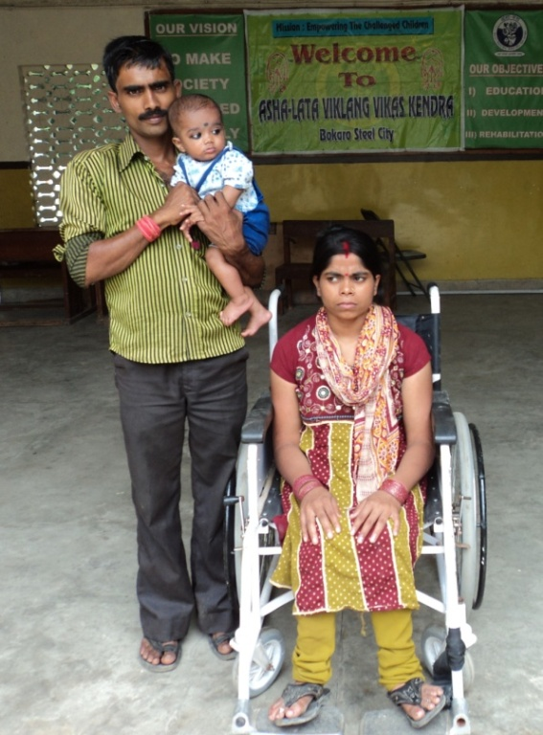 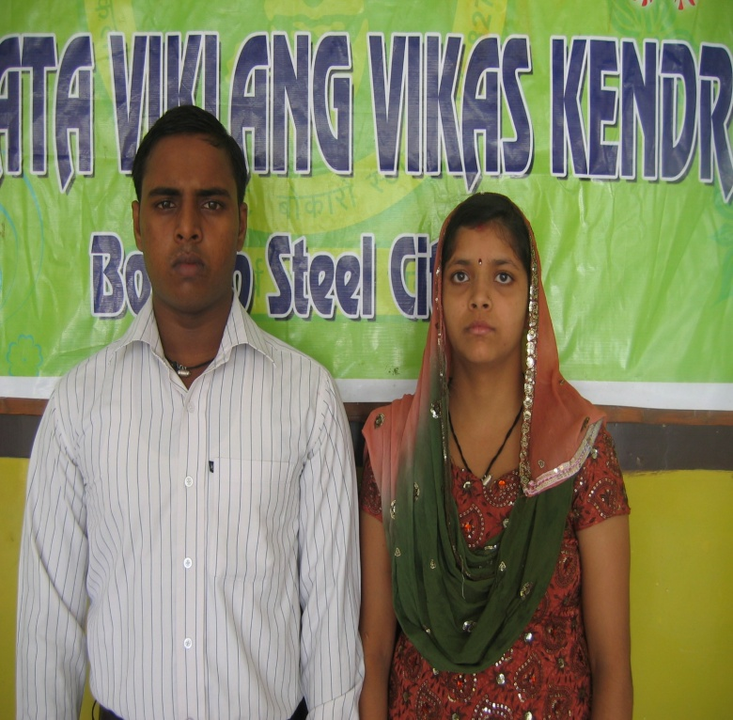

* **The following students of Asha-Lata have been married during 2013-2014 with normal spouses.**

|  |  |  |  |
| --- | --- | --- | --- |
| S.No | Name | Disability | Spouses |
| 01. | Kavita Kumari, B.A, B.Ed | Visually Impaired | Kartik Kumar, B.A |
| 02. | Sweti Kumari, Diploma in Engg. (Computer Sc.) | Hearing Impaired | Arun Kumar, Employed in Govt. of Bihar) |
| 03. | Navin Kr. Jha | Visually Impaired | Kiran Kumari |
| 04. | Lovely Kumari | Intellectually Challenged | Sanjay Kr. Gupta (Employed in BSL) |
| 05. | Brahma Prakash Singh | Intellectually Challenged | Pinki Kumari |